

**Good Counsel College**

**Grade 10**

**Economics and Business**

**Student Booklet**

**UNIT STUDY:**  **Factors influencing consumer choice**

1. *Identify* the difference between minor and major consumer and financial decisions
2. *Describe* the processes involved in consumer and financial decision-making
3. *Explain* the factors which influence major consumer and financial decisions
4. *Evaluate* the short- and long-term consequences of major consumer and financial decisions

**Introduction\***

We all love to buy and consume things, bearing in mind we also must pay for them as well. It is important to understand the factors which will affect our decision-making and what could be the short-term and long-term consequences of these decisions.

This unit will focus on identifying and explaining the range of factors which influence our decision-making as consumers. Before purchasing an item, it is important to make an informed decision. To be an informed consumer means that you will identify your needs and wants, research product options and their features and compare the costs and benefits of items before you commit to a purchase. When consumers are informed, they have the power to make a financial choice that best satisfies their needs and wants.

When making decisions to purchase a major product or enter into a financial arrangement or commitment, a consumer must have a good understanding of what s/he is entering into. There will be consequences both short-term and long-term, because of these decisions. Understanding these consequences will help ensure a good decision is made when making a purchase or service.

Needs/Wants Factors to consider before purchase (research) Informed Decision Purchase Consequence

**Inquiry Questions**

What are the factors which influence our buying decisions?

What is opportunity cost? How does it impact our buying decisions?

Evaluate the outcome of making a major consumer and finance decision, such as buying a mobile phone

**Types of consumer decisions**

Consumers purchase goods and services to satisfy their basic needs and unlimited wants.

However, consumers usually have limited funds, so they are constantly forced to make decisions.

What to buy? Where to buy? How to pay for purchases?

1. **The difference between minor and major consumer and financial decisions**

Consumer decision-making refers to the ways individuals make choices about which products they will purchase to satisfy their wants and needs. The process depends on whether the purchase is minor or major.

*Activity: Create and complete a two-column table like the one below showing examples of minor and major purchases*

|  |  |
| --- | --- |
| Minor Purchases Examples: | Major Purchases Examples: |
|  |  |
|  |  |
|  |  |
|  |  |

1. **The processes involved in consumer and financial decision-making**

*Activity: The following statements relate to what consumers should do when making a major purchasing decision. Organise them into the correct order showing the consumer decision-making process.*

* Evaluate the product post-purchase to determine satisfaction levels (are you happy with your purchase)
* Collect information about product options
* Make a purchasing decision which considers the short- and long-term financial consequences
* Evaluate the product alternatives against a set criteria
* Identify needs and wants

1. **Factors which influence the buying decisions of consumers**

There are many factors which influence consumer decisions to varying degrees depending on whether the purchase is minor or major.

A consumer might purchase clothing based on social factors like what’s on trend ATM

Whereas buying a car is a major purchase and needs more consideration of personal and economic factors



The buying decisions of consumers are influenced by internal and external factors. External factors include: price, marketing strategies, finance, availability and cost. Internal factors include: personal influences like age, gender, life-cycle stage, occupation, economic circumstances, life style and personality. Social and cultural factors, psychological factors (eg motivation, beliefs and attitudes) are also examples of internal factors affecting decision making for consumers.

*Activity: Draw this cycle into your writing books. Extend the mind map with an example of each.*

**Personal factors**

Consumers are not all the same, they differ in age, gender, personality, life-cycle stage, occupation and economic circumstances. These differences impact their purchasing decisions.

The decisions you make as a young person will not be the same to those made by older people like your parents or grandparents. How might you pay for music compared to your grandparents? What type of holiday might a young person go on compared to a family with young children or mature-aged retirees? The financial commitments at each stage of life would influence the kind of holiday taken.

|  |  |
| --- | --- |
| **Factor** | **Explanation/example** |
| Age | * Families go through stages that create different consumer demand * For example, children want toys while adults want houses, cars or furniture |
| Gender | * Males and females often purchase different types of products |
| Personal tastes/requirements | * Preferences for items like fashion and food * For example, left-handed people prefer products that are tailored to their needs * For example, some people have special health requirements and require particular types of food such as gluten-free foods |
| Occupation | * Tradespeople need tools for their work while IT workers have a greater need to purchase electronic goods |
| Lifestyle | * Includes hobbies, interest, priorities, values and world views * Often influenced by location, for example, coastal, city and rural lifestyles all require different products |

*Activity: Why would you send your children to a Catholic school rather than a state school in our region (Babinda to Tully)? Identify reasons and analyse use a cost-benefit analysis table.*

<https://www.youtube.com/watch?v=TknPS-n1Cig> Catholic Education Cairns - Southern Region 3:45 mins

**Social factors**

Your social group will also influence your decision making. If you want to fit in with your group, you might buy products and services favoured by this group. Product endorsements and product placement are methods used to create a desire to purchase certain products so consumers can be just like others they want to copy.



*Think of advertisements you have seen recently that are using celebrities to sell products – endorsements. Are you likely to be persuaded by a celebrity when making a financial decision to buy something?*

**Social factors cont’d**

Word of mouth within a peer group is also a powerful way to positively or negatively influence consumers’ purchasing decisions. Asking your friends, internet reviews and conversations with family prior to making a purchase can be helpful for consumers. Increasingly, more people are relying on online reviews to decide about purchasing a product or service.

*Activity - “The internet is increasing in popularity as a place where consumers are seeking product information to assist them in making their purchases.” Discuss whether you believe this way of finding out about a product will ever become the sole source of information, instead of seeking the advice and opinions of peers and family.*

Consumers are also influenced by values and beliefs from their family, culture, religion, nationality and peer groups. If you have strong views in particular areas this can influence your buying decisions. For instance, ethical and environmental considerations may be crucial in deciding what you buy. The way in which the product was sourced or manufactured ethically might be important to the consumer. For example, would you purchase chocolate where the cocoa was sourced from plantations using child labour? Would you buy a product from a company who polluted a major river with their industrial waste, killing off fish supplies?

Status and fashion are important considerations for some consumers. Teenagers are ‘brand’ conscious. eg they will buy Mambo, Nike, Billabong even though other similar products may be cheaper or better quality. Older consumers are also brand conscious. They will buy Westinghouse white goods for example, over another lesser-known brand because Westinghouse has been around for a long time. They think, “it’s been around for years, it must be ok”.

People will also buy expensive brands because of the status they represent. They will buy a particular make or model of car because it is associated with an image that they want to display. For example, Mercedes Benz are often linked with wealth and success, whilst V8 Holden and Ford models are associated with masculinity and personal power.

|  |  |  |
| --- | --- | --- |
| CLASS/STATUS |  | SOCIAL PRESSURE |
| Products are targeted at different ends of the market, for example:   * The upper class generally choose more high-end, luxurious products * The middle class choose products that make a secure future * A personal struggling financially will purchase products for survival |  | Choices are influenced by social pressures, such as:   * Trends and fads (consider fitness, health and nutrition) * The word-of-mouth recommendations of reference groups like family and friends * Expectations of particular social roles (mother, husband) * Celebrity endorsements |

*Activities*

1. Brainstorm list of brands popular with teenagers

Select five of the brands identified – what images are used to appeal to the targeted market?

1. Write these products names down. Coca-Cola, Kmart, Qantas, Vegemite, Mercedes Benz. Which of these words would you associate with these products – safe, Australian, value for money, luxurious, fun-loving
2. Imagine you are introducing a new product for teenagers. Write down five words you would want associated with this product.

**Economic factors**

When purchasing large ticket items, consumers will often not have sufficient savings and will need to borrow money to make the purchase. Many consumers use credit through their credit cards to purchase items. However, if they do not repay the full amount owing on their credit card each month, they can owe interest at a high rate and get themselves into a debt cycle. Using After Pay and other pay later services still mean the consumer is using credit to pay for products and services they don’t have the funds to pay for at the time of purchase. If a loan must be obtained to pay for a major purchase, the consumer must be able to repay it back in regular instalments over a payment period. The last thing any consumer wants is to get a poor credit rating. This is where someone is a slow payer and doesn’t pay on time for items or services purchased on credit. They get a bad name and it affects their ability to borrow money in the future.

For most consumers, the price of products versus the ability to pay are the most important factors influencing purchase decisions.

|  |  |  |
| --- | --- | --- |
| PRICE |  | ABILITY TO PAY |
| * Budget constraints limit the amount of money you can spend on a product * Price points may also influence your perception of the quality of a product * Unit pricing and comparison rates are often used to compare the value of different goods and services |  | * Major purchases often require loans or use of credit from financial institutions * The ability to make loan repayments with interest over a number of years influences the purchasing decision * Insurance, asset depreciation and legal fees are other costs to consider |
| WARNING: Many products and service come with hidden costs such as installation charges, excess payments or postage and handling costs that must also be considered. ALWAYS READ THE FINE PRINT! | | |

**Psychological factors**

This relates to the level of motivation a consumer has when purchasing a product. Consumers have specific beliefs and attitudes towards various products and this relates to brand image. Marketers understand this and will launch special campaigns related to gaining customer loyalty and commitment to their brand.

Psychological factors that influence consumer purchasing decisions include motivation, perception, learning and beliefs and attitudes.

|  |  |  |
| --- | --- | --- |
| Perception | Learning | Beliefs and attitudes |
| * This is the process by which consumers select and interpret information to make purchasing decisions * Differences in perception mean that individuals with the same needs still might choose different products | * This refers to the changes that occur in a consumer’s buying behaviour after they gain information or experience with a product * If consumers know and are satisfied with a product, they will often buy the same product again | * People purchase goods and services based on their thoughts and feelings about a product or its brand image * Consumer attitudes tend to be enduring and are often difficult for companies to change |

**Psychology and marketing: Impulse buying vs Planned buying**

Marketing of products is a major factor influencing consumer decisions. Marketers understand the role that psychology plays in consumer behaviour and use this knowledge to promote their products accordingly. The purpose of some advertisements is to disrupt the decision-making process by enticing consumers to make purchases based on emotion without a full evaluation of the alternatives.



During summer, driving to Townsville can be very hot. When you see the Frosty Mango sign, instantly you desire an ice cold treat to cool down! Works every time!

The purpose of marketing is to raise the consumer’s awareness of a product and to create a positive image about that product or brand. It aims to create your sense of need for a particular product. Businesses use many marketing strategies and promotional tools to influence and encourage consumers into purchasing their product. Sales promotion and incentives (2 for 1 offers), product endorsements by celebrities, ’trusted people’ eg doctors/scientists etc are examples of promotions.

*What are some advertising methods you know of? Which ones do you think are the most effective?*

When consumers are deciding whether to purchase a particular product they may be influenced by information-based marketing. This is where the facts about that product are provided to connect on an intellectual level with the consumer, to encourage them to make an informed decision about the purchase.

Humour is also used to help consumers make decisions. *Watch the special campaign by Meat and Livestock Australia.*

Australian Lamb Ad 2021: Make lamb, not walls <https://www.facebook.com/watch/?v=853670008525999> [https://www.mla.com.au/marketing-beef-and-lamb/domestic-marketing/lamb-campaigns/#](https://www.mla.com.au/marketing-beef-and-lamb/domestic-marketing/lamb-campaigns/)

*Answer the following questions after watching the marketing clip:*

1. *What makes the campaign special?*
2. *How does the campaign encourage brand loyalty?*
3. *What do you think the target market’s need are?*
4. *How do psychological factors fit in with the campaign?*
5. *Would this campaign change your buying habits regarding lamb?*
6. *Identify the elements of this campaign that make it clever advertising.*

**Cultural factors**

Cultural factors refer to the set of values, behaviours and ideals that are shared by a group of people (nationalities, religions, locations). Culture is a powerful influence on all consumer decisions such as what people buy, how they buy and when they buy. For example, consider how food choices are made along cultural lines.



I’m an Australian Muslim but my cultural background is Iranian. This has definitely influenced my preference for Middle Eastern foods and my clothing choices.

**Ethical factors**

The role of personal ethics or values in consumer decision-making has become more important for consumers these days. Today’s consumers tend to be more socially and environmentally aware of the impacts of their purchases. They want to purchase items or services from responsible businesses who value human rights, equality and the environment.

Only buy stuff from industries who care about greenhouse gas emissions!



I only use make-up that has not been tested on animals!



*Activity: cut and paste each of the following factors into the correct column of the table below:*

|  |  |
| --- | --- |
| Social factors | Environmental factors |
|  |  |
|  |  |
|  |  |
|  |  |
|  |  |
|  |  |
|  |  |

Animal welfare

Recycling

Fair trade practices

Waste disposal

Health and safety of workers

Sustainable use of resources

Greenhouse gas emissions

Factory (sweatshop) conditions

Packaging

Genetic engineering

Air/water pollution



*Example of corporate social responsibility by Westpac Bank*

*Would this sway your decision to bank with Westpac?*

*Activities*

*Highlight the correct answer for each of the following multiple-choice questions*

1. *Which of the following is an internal factor that could influence the purchasing decision of a consumer?*
2. *price*
3. *lifestyle and personality*
4. *marketing strategy*
5. *availability of finance*
6. *An opportunity cost is:*
7. *the costs subtracted from the benefits*
8. *reducing value of an asset over time*
9. *the benefits given up on an alternative by making the current decision*
10. *a sharp decrease in the price of a product*
11. *Which of the following is an external factor that could influence the purchasing decision of a customer?  
    a. gender of a customer*

*b. motivation of customer*

*c. cost of finance*

*d. social status of customer*

1. *Which of the following goods is likely to show price inelasticity?*
2. *caviar*
3. *magoes*
4. *wild salmon*
5. *wheat*
6. *Which of the following holiday options is most likely to suit the financial situation of a student?  
   a. cruise in the South Pacific*

*b. Camping holiday in the Victorian Alps*

*c. Skiing in the French Alps*

*d. A week in New York*

1. *Kristie wants to buy the same car as her sister Di, who owns a Landcrusier (4wheel drive). Di has a family of 3 children. They go on a lot of camping holidays. Kristie is 17 and in her last year of school. Do you agree with Kristie’s choice of car? Prepare a cost-benefit analysis of Kristie purchasing the same car as her sister.*

**Summary**

Consumer decision-making refers to the process by which individuals make choices about which goods and services they will purchase to satisfy their wants and needs.

When making major financial decisions such as purchasing houses, cars, investments, consumers should take care to fully evaluate a range of factors. This will help to make wise choices and achieve the consumer’s objectives. It is especially important when the consumer decision carries a major risk or severe consequences to the buyer if they make a mistake.

With every purchase made there is an opportunity cost. A cost-benefit analysis will determine the benefits and costs associated with making purchase for goods and services.

1. **Consequences of major consumer and financial decisions**

When consumers make any purchase, they are said to have incurred an **opportunity cost**. Opportunity cost means the alternative you must go without in a choice between two competing things or events. This means if you had decided not to spend your money purchasing one item, what benefits could you have gained making a different purchasing decision? For example, if you decided to visit a café every day to buy a bottle of water, you would have incurred a cost of $10-$15 per week.

By making the decision to buy water, instead of filling a bottle with water from home, you have reduced your savings by the $10-$15. Over a term, this would add up to $100-$150 that you could have used for something else! After all, water is free.

A **cost-benefit** analysis is another way of analysing and assessing your purchasing decision. The benefits gained by making the purchase need to be identified and added up. Then subtract the costs that will be incurred in making that purchase.

**Short- and long-term consequences of major consumer and financial decisions**

Consequences of consumer decisions

* As well as considering the six types of factors when making decisions, consumers must also evaluate the short- and long-term consequences of making purchases.
* Consequences are the results or effects of decisions and can be:

|  |  |
| --- | --- |
| Short-term or long-term | The length of time that the result is in effect |
| Positive or negative | Whether the effect is beneficial or detrimental |
| Intended or unintended | Whether the effect was evident or foreseeable during the decision-making process |

Short-term consequences

* While most people are aware of the direct costs of life, many ignore the indirect costs associated with those actions.
* In the short-term, for every consumer decision, trade-offs need to be made and opportunity costs are involved.
* At its core, an opportunity cost is what you lose by choosing one alternative over another.
* This extends beyond just the monetary costs of a decision, but it includes all real costs of making one choice over another, for example, the loss of time, energy and even the pleasure or utility derived.

Long-term consequences

* Longer-term consequences are sometimes less obvious.
* As well as the initial purchase price of a product, the ongoing recurring costs of operating, maintaining and insuring goods and services must also be considered.
* Not making a particular consumer or financial decision can also have long-term consequences that cost thousands of dollars over a lifetime.



A major financial decision

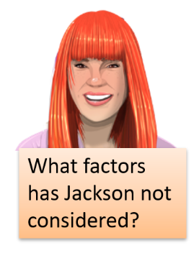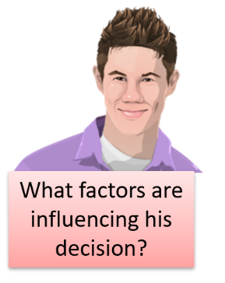This is 18-year-old Jackson. He recently left school and still lives with his parents. His girlfriend Juliet has spent the last year working as a receptionist and saving to fund an overseas trip backpacking around South-East Asia. She has paid for her ticket and saved $8 000 to fund her travels for six months. Jackson wants to go with her and is deciding whether to take out a personal loan to fund his trip. What should he do?

What factors are influencing his decision?

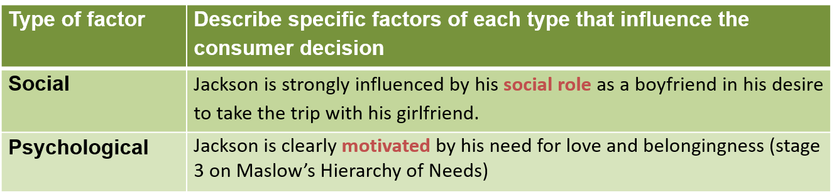

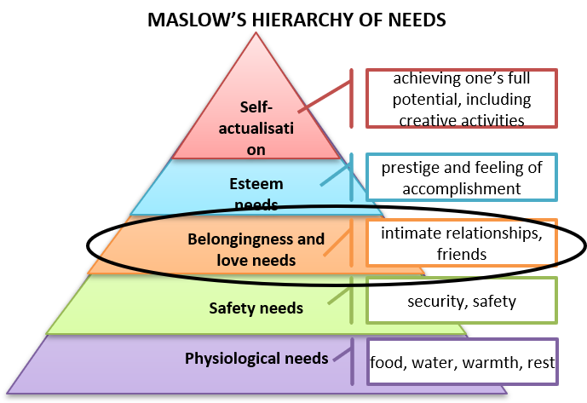

What other factors should influence his decision?

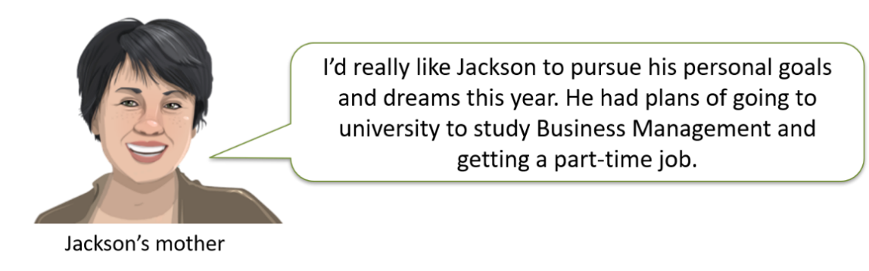

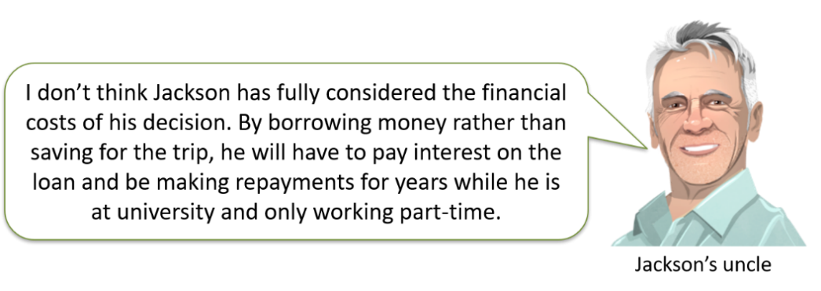

Short- and long-term consequences of decisions

After considering the full range of factors and evaluating the potential outcomes of his decision, Jackson decides not to take the trip due to the severe long-term financial consequences.

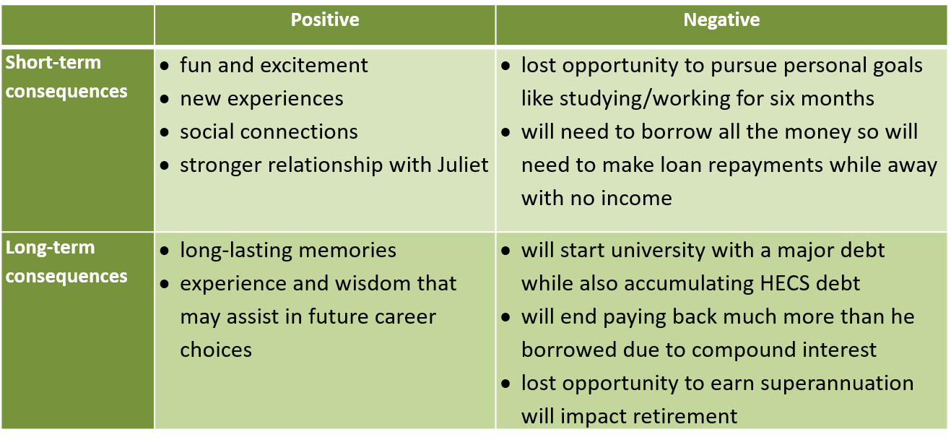

**Making a major purchase**

1. You are going to purchase your first car. Create inquiry questions that show the research you would need to undertake in the decision-making process.
2. Evaluation: having undertaken this research, do you think that you can actually afford to purchase, maintain and insure the car of your choice or do you need to modify your expectations?

**Summary**

Most people are aware of the seen costs when it comes to making major consumer and financial decisions. However, the unseen costs can be more important to realise. Understanding the short- and long-term consequences of our decisions can make it easier to make good personal choices.